**MICROPROCESSOR LAB**

**CODE EDITOR : MICROPROCESSOR 8085**

**OBJECTIVE** : WAP TO ADD TWO HEXADCIMAL NUMBERS

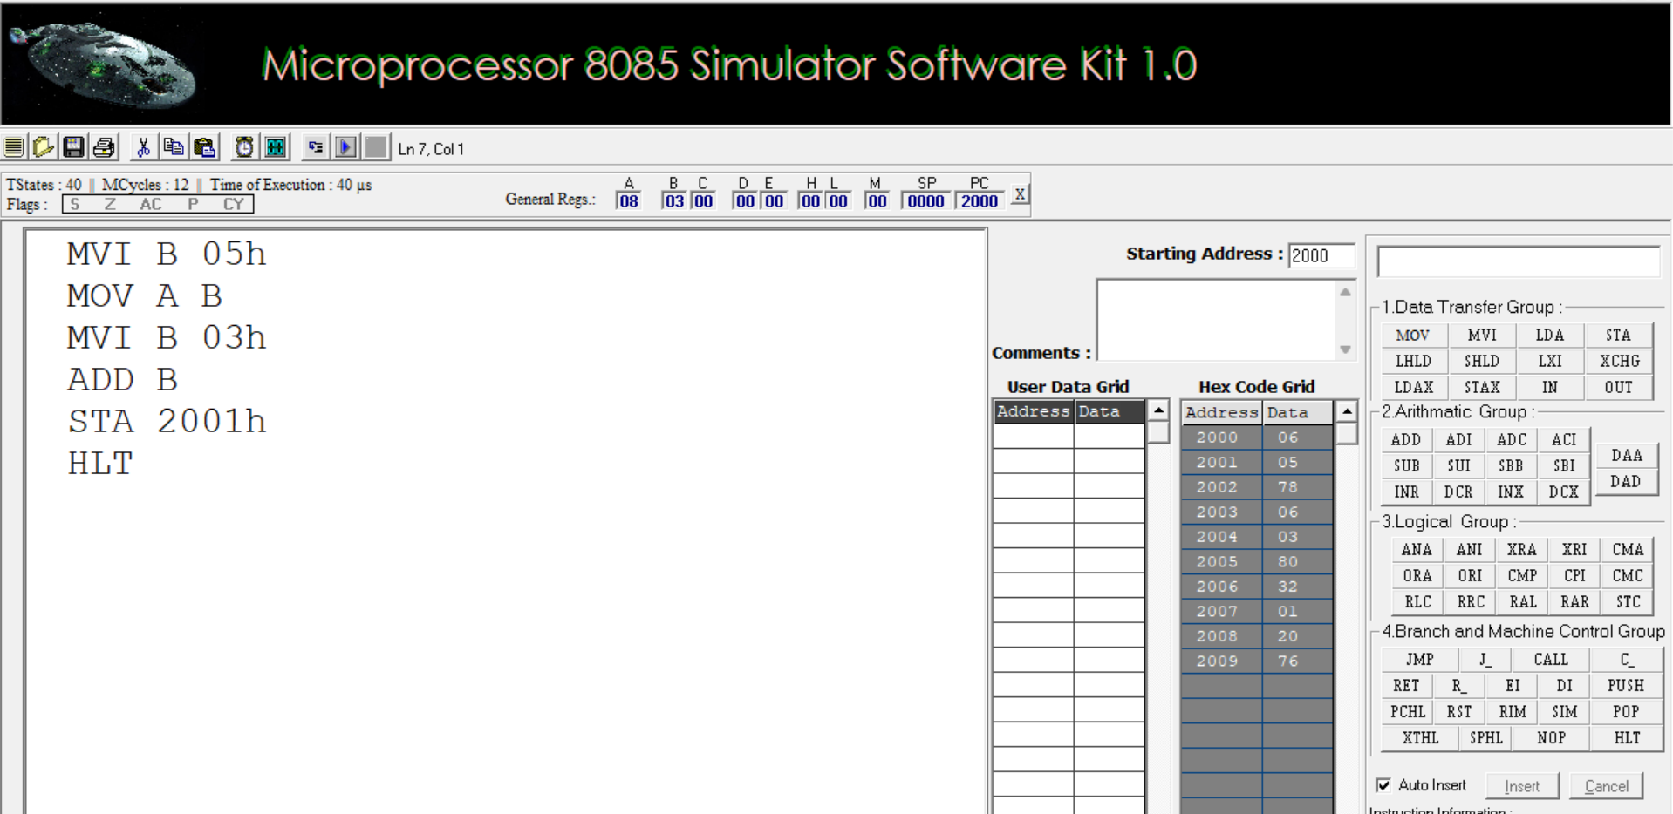

**OBJECTIVE :** WAP TO SUB TWO HEXADCIMAL NUMBERS

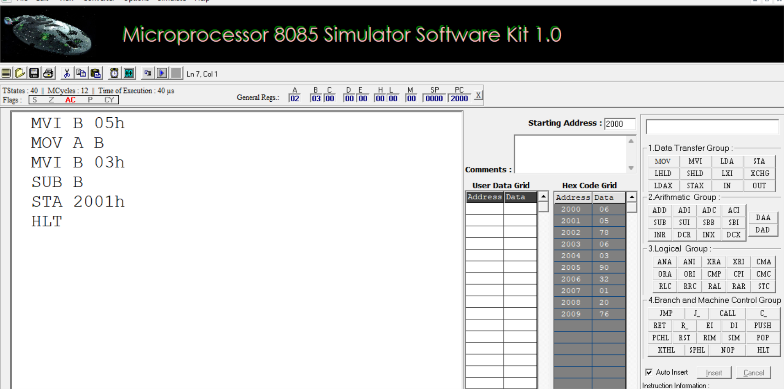

**METHOD -2**

